Paper Title

Arrhythmia Detection Using Deep Convolutional Neural Network With Long Duration ECG Signals

1. **Preprocessing: Filtering & Segmentation**

**Using signal rescaling to the range [-1,1]**

No signal filtering.

No QRS complexes detection and segmentation.

1. **Feature Extraction**

Deep Learning Approach in the next point.

1. **Classification & Classifier**

**1D-CNN**

a 16-layer deep network structure including standard CNN layers was designed. The input of this network structure comprised 3600 samples of long-duration raw ECG signals. At the classifier network output, prediction of the classes to which the signals belong had been provided. Unlike standard techniques, no QRS detection and segmentation was performed on the ECG signals. Comprehensive performance evaluations of the network were made on the ECG database containing 1000 fragments. In experimental studies, results were obtained on different cases using 13-, 15- and 17-classes.

1. **Accuracy**

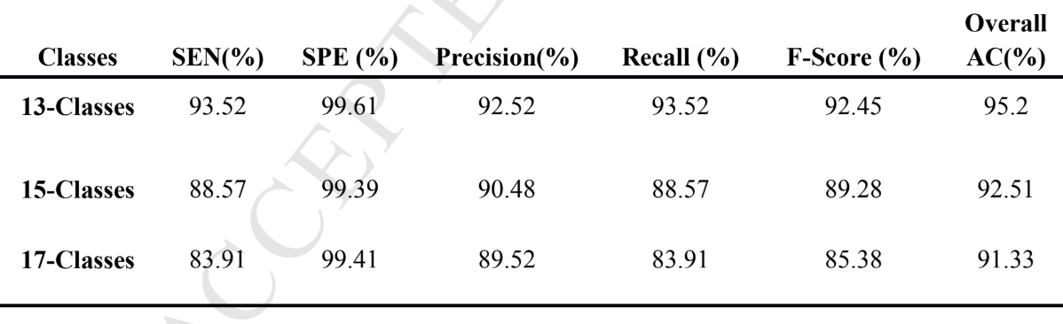1D-CNN model achieved an overall classification accuracy of **91.33%** for 17 cardiac arrhythmia (classes), with classification time of **0.015 s** for analysis of each 10-s ECG sample.

1. **Two Leads or One Lead ? In case of two leads .. how classification of two leads is merged to have final decision ?**

One Lead.

1. **Classes**

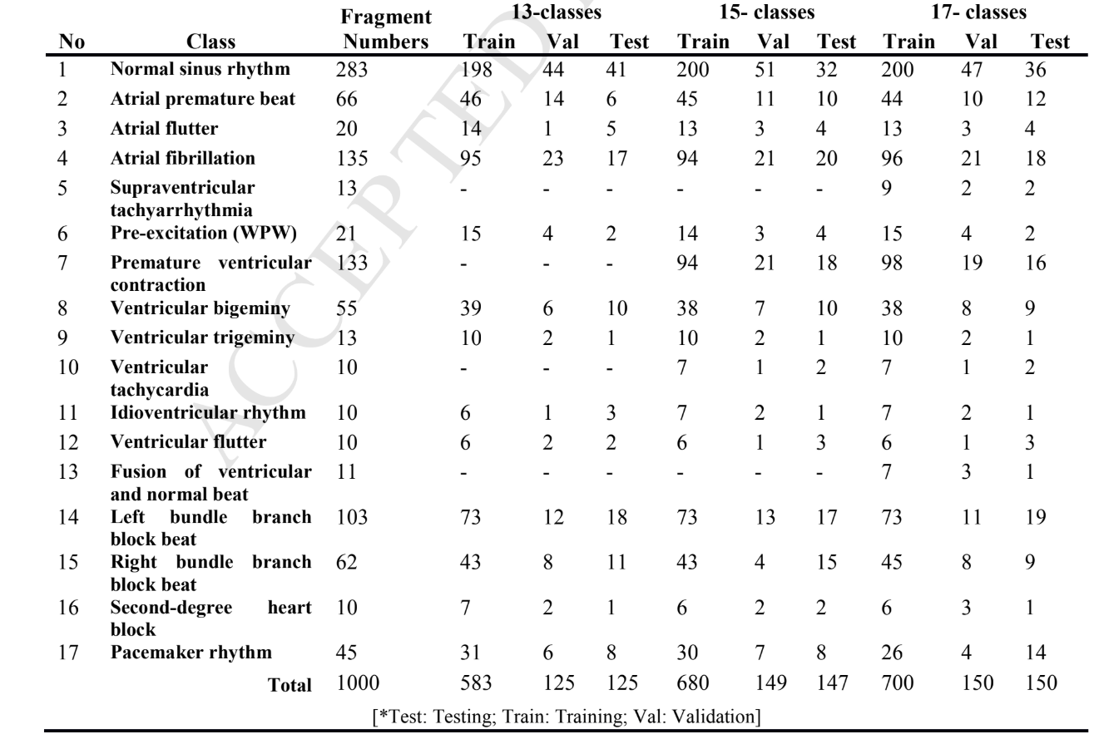**17 Classes**

